TASK 1

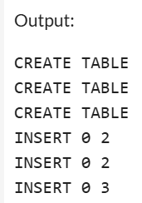

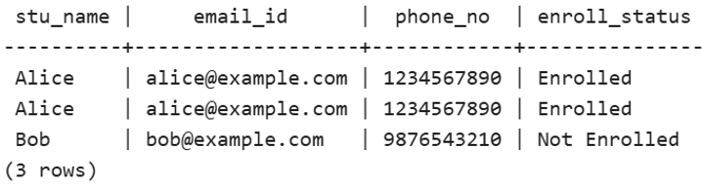 3a) Student details + contact + enrollment status

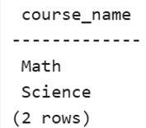 3b) List of courses for a specific student

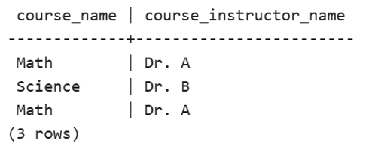 3c) Course info + instructor

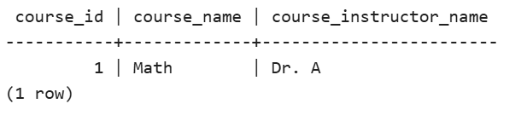 3d) Courses for a specific course name

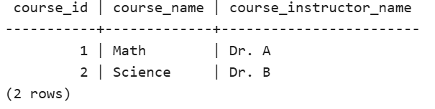 3e) Courses for multiple courses (IDs 1 and 2)

3f) Ran all queries together to verify output

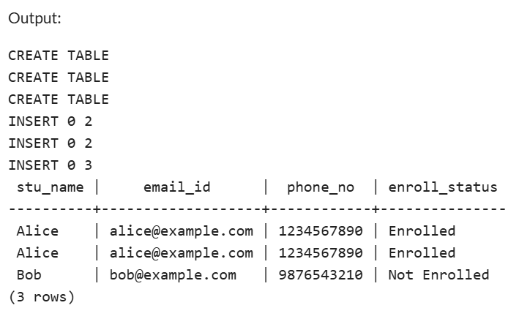

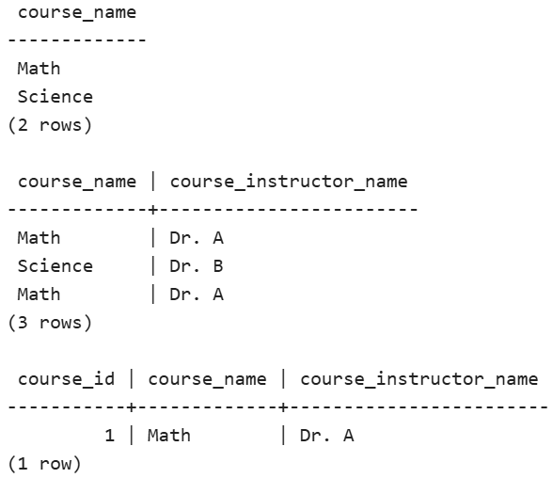

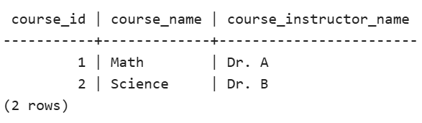

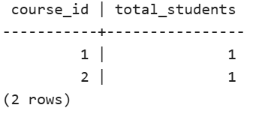 4a) Number of students in each course

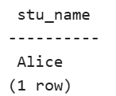 4b) Students in a specific course (ID = 1)

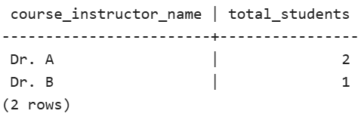 4c) Count of students per instructor

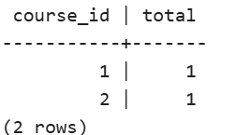 e) Courses with highest enrollments

TASK 2

3. Retrieve all students sorted by grade

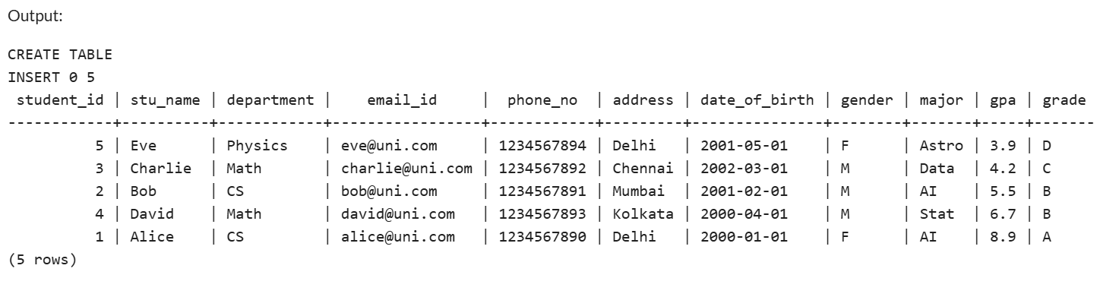

4. Male students only

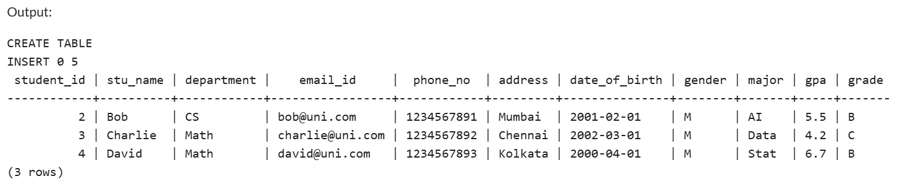

5. GPA < 5.0

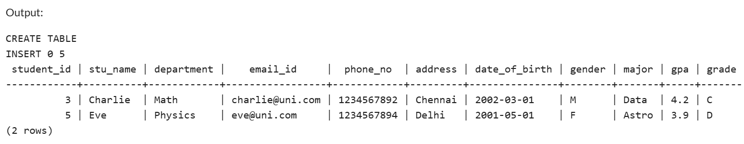

6. Update email and grade

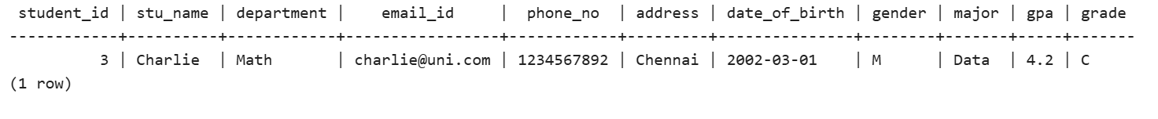

7. Students with Grade B

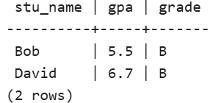

8. Group and calculate avg GPA

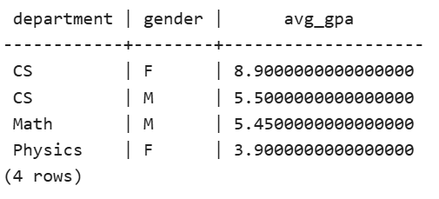

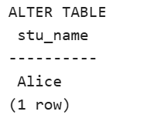 9. Rename table & 10. Student with highest GPA

TASK 3

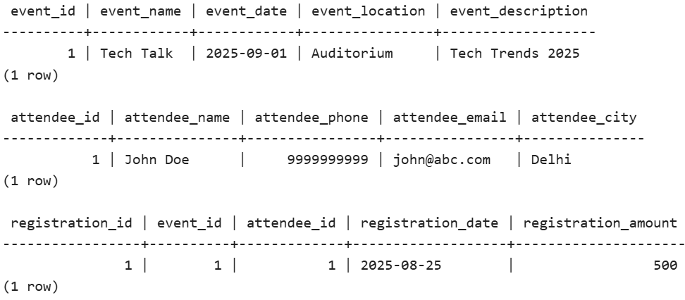

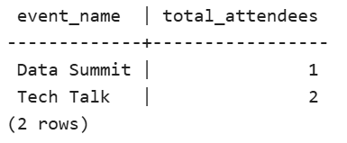

TASK 4

a) Drill down: sales by region then product

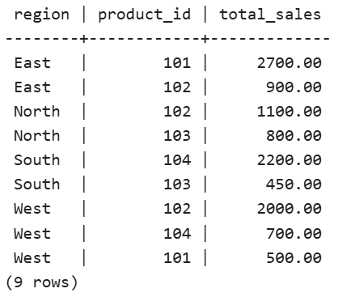

b) Rollup: product -> region

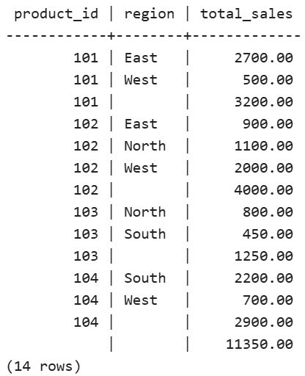

c) Cube: product, region, date (example using date_trunc month)

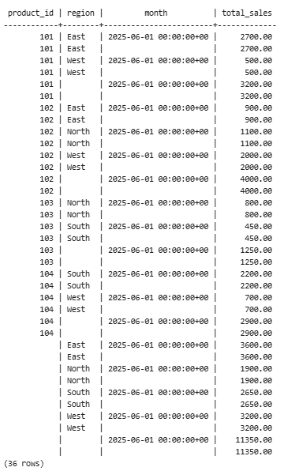

d) Slice: filter by region or date range (region = 'East')

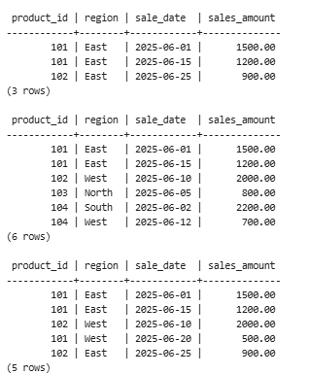

e) Dice: multiple criteria (product IN (101,102) AND region IN ('East','West'))